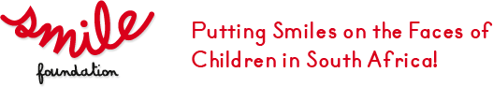

UNIT/LESSON PLAN

DATE: October 2012
GRADE: Foundation Phase Lesson/Unit Duration: 30 min
Life Skills
Topic: Smiles

Smiles are very important; they show others that we are happy. We smile when we want to connect with others. Smiles are so important that cameras are made which take pictures automatically as soon as someone smiles…. This is called Smile Recognition technology.

There is a Unilever ice-cream vending machine that recognises smiles. As soon as the machine detects that someone is near it beckons them to come closer and interact. If your smile is wide enough, the machine will give you a free ice-cream.

(SapientNitro Unveils World’s First Ever Smile-Activated Ice Cream Vending Machine for Unilever, June 21 2010, http://www.sapient.com/en-us/News/Press-Releases/a1422.html)

One smile can bring about new opportunities, new futures and new lives and that is why the SMILE FOUNDATION is trying to help children with facial deformities so that one day they can smile as wide as they want. The SMILE FOUNDATION is a non-profit organisation that brings people together. It provides surgery for children who suffer from physical deformities such as, cleft lip and palate, burn victims, Moebius Syndrome (facial paralysis) and other conditions.

The SMILE FOUNDATION is very proud of their Smile Weeks where many children are operated on, parties are held and celebrities are invited to join in on the fun. The children’s ward is packed with fun filled activities, love, and excitement. It is truly the place to be.
The SMILE FOUNDATION website is www.smilefoundationsa.org.

Here is an explanation of some of the physical deformities:
Cleft lip and palate:
“Cleft lip and palate is a gap or split in the upper lip or roof of the mouth, or both. It happens when a baby's lip and roof of the mouth don't join properly during pregnancy” (Cleft lip and Palate, published by Bupa's health information team, Publication date: June 2009).
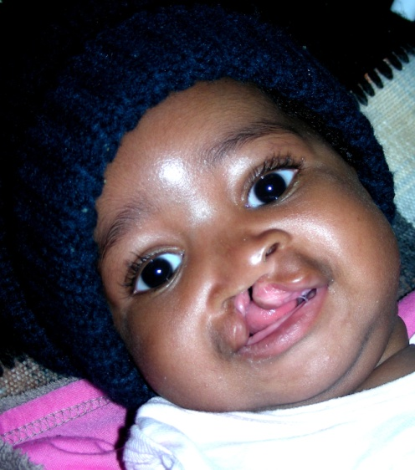

Lesson one:

Overview
What qualities do you want in a friend?

Equipment:
Work book page 4 and crayons or coloured pens, Sticks, stars, smile.

Activities

- Sit in groups of 4 around a table make a wand so you can make magic.
- Close your eyes and imagine that you have the power to create a new friend; one who is your best friend ever…. (Best friends make you smile when you think of them…)
- Draw a picture of your new friend in your work book; put in as many details as you can.
- Name the qualities of this friend which makes you smile e.g. gentle, funny, brave, honest, pretty, good looking :
- Choose the qualities from the board that are qualities you want in a friend and put these qualities in the space provided around the picture.
- Share the qualities you have chosen with your friends at your table; see how many of them are the same. Do you all choose the same qualities in friends?

UNIT/LESSON PLAN

DATE: October 2012
GRADE: Foundation Phase Lesson/Unit Duration: 30 min
Life Skills
Topic: Smiles

Lesson two:

Overview
What do I do which hurts or heals my friends?

Equipment:
Work book page 5; scissors; pens; paper

Activities

YOU ARE A SURGEON FOR THIS EXERCISE:

Surgeons are careful. They are responsible for detailed operations where they change people’s lives. Surgeons care for the people they operate on. Surgeons are very clever and take great care in their work. So for this lesson you are going to be surgeons and perform an operation.

- Take a good look at the picture in front of you in the workbook: you will see that it is a face with puzzle lines drawn on it.
- Cut out the picture and then paste it on cardboard.
- Now carefully cut out the puzzle pieces.
- Mix up the pieces and put the puzzle back together; but leaving out the “mouth” piece so that there is a “hole” or ”gap” where this piece used to be.
- Look at the face now and see how it is different without the mouth piece...everything has stayed the same except the mouth; but the face looks different. Share with your teacher and classmates what you see now.
- Trace the shape of this piece of the puzzle (the mouth piece) onto a new piece of paper and then cut out a new piece; so you have an identical piece to draw on.
- Get together with a partner in this part of the activity and study each other’s faces: smile at each other; grin at each other; laugh; show anger; frustration and unhappiness
- Now take your new blank puzzle piece and draw a new happier expression onto it: it could be a smile or a grin
- Replace the old “mouth” piece with this new piece so that the person in the picture now looks happy
This is what the Smile Foundation does: the surgeons who work for them determine what they have to do to put a Smile on the person’s face and they work carefully to put a new smile on a child’s face. You have just completed your first Smile Foundation operation. How does it feel to give this gift to someone?

You have the power; just like the surgeon, to take away someone’s pain and replace it with a Smile. Consider the actions you take each day which do the following:
- Take someone’s pain away
- Put a Smile on someone’s face

Take 10 minutes and put on a role play (with your partner from the earlier activity). You are going to role-play 2 interactions which would take the Smile off someone else’s face; and 2 interactions where you put a Smile on someone’s face. These interactions could be those which involve ACTIONS or something you SAY.
When you have practiced and can share these interactions with the class your teacher will give you all a chance to show your role play to the rest of the class.

When you have all shared please help your teacher write up all the actions which hurt and all the actions which heal. These can be done on a poster for the wall or on a blackboard to remind us to heal; not to hurt.

UNIT/LESSON PLAN

DATE: October 2012
GRADE: Foundation Phase Lesson/Unit Duration: 30 min
Life Skills
Topic: Smiles

Lesson 3:

Lesson Outcome:
Children will discuss the importance of qualities in a friendship over physical characteristics and even children who look different are the same inside.

Overview:
Real life story

Equipment:
Pictures are supplied
Bongani’s life story (in workbook page 6)

Activities:

- Take a good look at the picture of the child in the notes
- What do you think of this person?
- How did you feel when you looked at the picture?
- Where in your body did you feel this feeling?
- Have you ever felt like this before? ... If so when? Explain your story.
- What do they look like?
- Why do you think they look like that?
- Would you talk to this person?
- Could this person be your friend?
- Listen to the story about Bongani.
- Look at the picture again:
Now what do you think about Bongani? Share this with the people at your table.
- What qualities do you think this person has? Name those qualities and your teacher will write all these qualities down on the board…write them down next to the picture of Bongani. Are these qualities the same as the ones you wanted in your special friend you drew in Activity one?
- Does Bongani have any qualities you may want in a friend?

UNIT/LESSON PLAN

DATE: October 2012
GRADE: Foundation Phase Lesson/Unit Duration: 30 min
Life Skills
Topic: Smiles

Lesson 4:

Overview:
What makes you special?

Activities:

- Sit in a circle of five.
- Recap the story about Bongani.
- What makes Bongani special? Share some characteristics and traits.
- Look at the person to the left of you and tell them what you like about them. What makes them special? Carry on until everyone has said something about the person next to them.
- Remember some of the qualities you discussed in the other lessons; you may remember the words you used to describe your friends in the last lessons.
- Did you like what they said about you?
How does this make you feel?
How does it make YOU feel to say special things about other people?

